Newsletter ………………..Mijoy Yorkies
MAY 2009

Hi to you all.

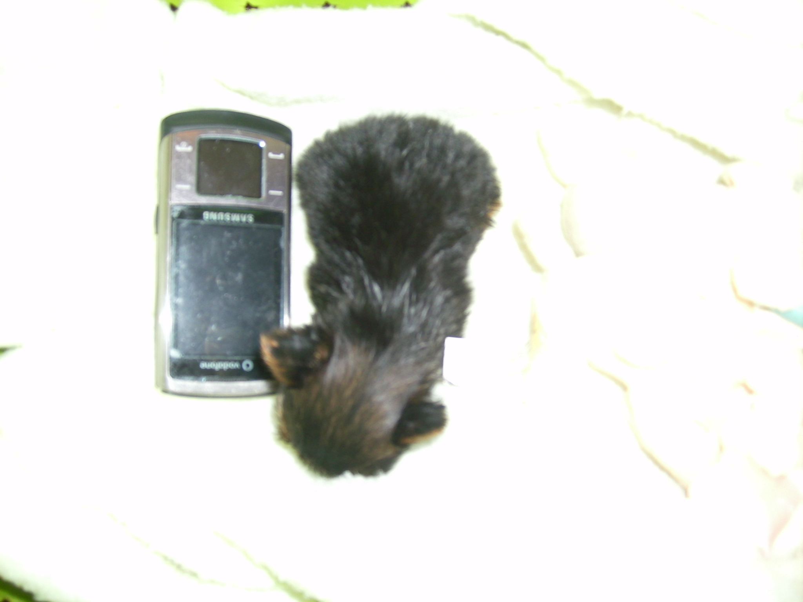
Figure 1Pixiedoll 4weeks and five days old

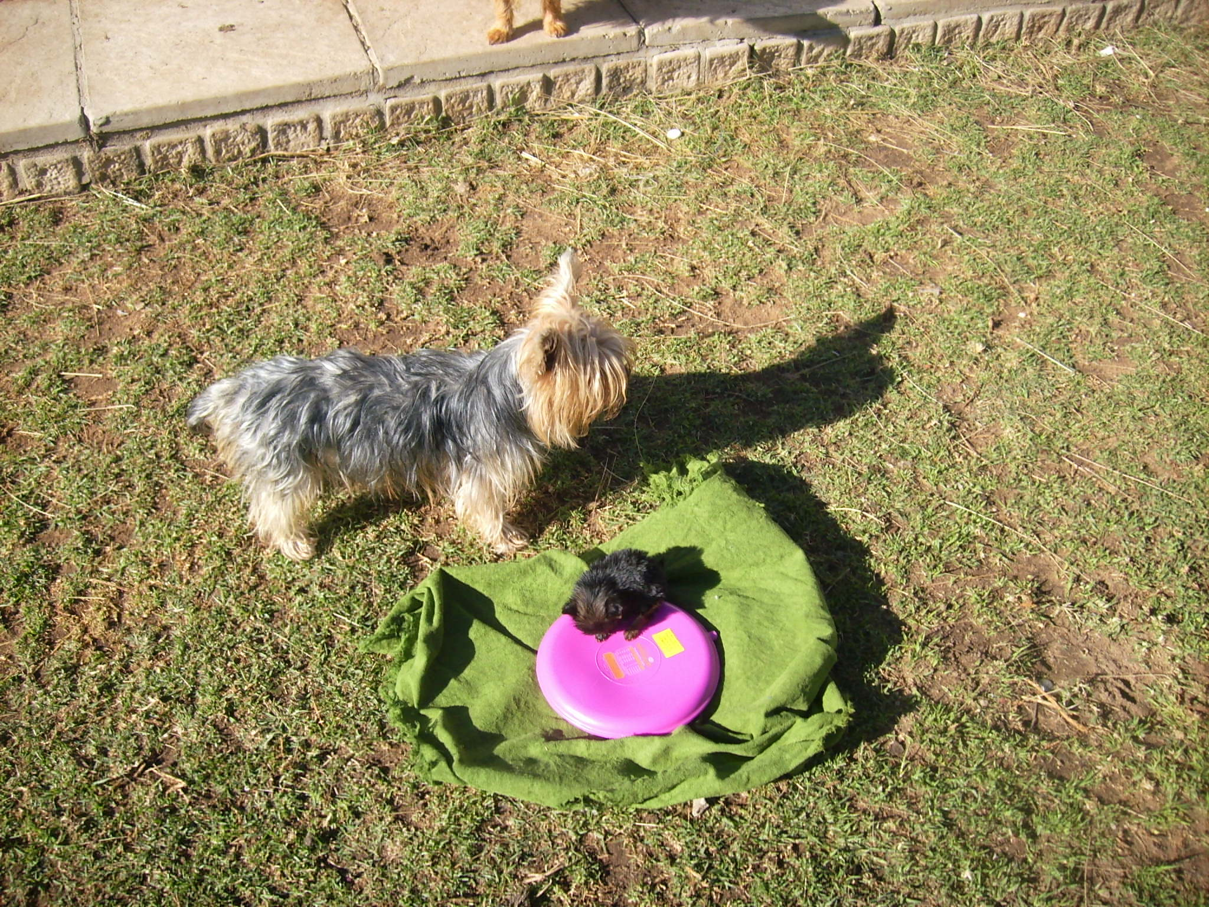
Pixiedoll - 6 weeks old

Blingdog specials. Jerseys in most sizes suitable for the pocket medium size and larger yorkies (too big for teacup - sorry…………….. greatly reduced price of R100-00 each. Limited stock., from the House of PUCCI imported from ENGLAND

Snugglesafe microwaveable pad R410-00 each. Lasts for hours on end. Totally safe, washable. As seen in pic 2 above. (however please do not leave on uncovered item. One in the pic barely warm at that stage.

Rubber mats, last a lifetime. Excellent quality R400-00 each. Large size. – guaranteed not to overheat. We are looking at bigger sizes of 1000 x 1200 selling for R550-00 for all the pooches to warm up on. The bigger size will be on order only.

Enquiries for the above: mijoy@wam.co.za P & P not included in price.

CONTRACTS: Kennel Union of South Africa, recommend you sign a contract on the purchase of your pup. This protects both you the owner and the breeder in the event of something going wrong???? It also makes your rights and the breeders rights clear on any subject of health issues etc. Sterilisation etc.
IF for any reason the purchaser does not sign the contract when leaving our property with baby in hand. You are asked to complete and return the contract in a couple of days……… a lot of you are emailed the contract prior to receiving the pup. It is made very clear on our website and in any correspondence between us, that we expect you to complete and return the contract supplied.

“IF” no contract has been signed – regrettably your dog will not be registered and the microchip information will still remain in our name. If you have not completed all the information required, we will not be in a position to fill in the relevant Identipet registration form. It is therefore in your interests to return the relevant contract and all the information requested. Furthermore, no health guarantees will apply.

PLEASE do not think that failing to do the above, allows you carte blanche with the dog you purchased from us. Verbal contracts are binding. Therefore IF we ever suspect our dogs are being used with no authorized breeding permission in writing from ourselves, we reserve the right to take the necessary action to recover that animal. Proof of the animal being the said one, will be easily identified via the microchip.

NB no pup/dog leaving our property is approved for breeding. Therefore no “mistakes” will be approved. Sterilisation is not negotiable.

Recently I had a mail from a purchaser asking for her registration papers. No contract had been received from her although, repeatedly requested. HER DOG HAS NOT BEEN REGISTERED and NO obnoxious remarks will be entertained either.

Please note: If you have sterilized your pet and are waiting the registration papers, they will be with your shortly. I had a mail from Kusa yesterday,apologizing for the delay, but to the best of their knowledge the back log had now been sorted. IF you do not sterilize your pup as per my contract, NO registration papers will be handed over, and you do risk your dog being REPOSESSED……………. As per the contract.

Good Morning Joyce

As always your newsletter is a pleasure to read and full of excellent advice. I want you to place the following in your next newsletter.

I have been to visit the Mijoy Family and was pleasantly surprised. So much love! Joyce and her family are modern day Saints where animals are concerned and all at their own expense. I saw the “rescued” animals, all now loved and loveable. Some of them for obvious reasons cannot be re-homed but have found a home at Mijoy and are happy. Nowhere was there a tail between the legs or ears drawn flat against the head, one and all were running around enjoying the life they would never have had if Joyce did not take them in.

Anyone that takes in a Mijoy baby, whether it is a Yorkie or not, can be certain of a well bred, lovingly cared for and medically looked after healthy baby!

I take my hat off to the Mijoy family and thank God there are people like you!

Yorkie Love
Corlia

Thanks for visiting us Corlia with your lovely daughter. We appreciate your mail to us.
Corlia and I have been email friends for a long long time.

Hi Joyce

I would just like to thank you for the time you took showing us your wonderful yorkies, last Saturday. They are truly unreal little dogs, and you must be so chuffed to be the breeder and owner of them.
We had no idea such small dogs existed, and we have been to many a breeder in the last few months. We have often left with very unpleasant and mixed feelings on what Breeders are all about. I would like you to put this on your site, so the public are aware, that you most certainly go that extra mile.

Just to put your readers in the picture. I have been mailing Joyce for the last few months. She kept telling me she had a waiting list etc. for the very small yorkies and could help me if I were not in a hurry. We of course decided to do our research and homework and felt in the beginning, we would find our perfect pup in no time. Well we did see some rather cute pups that I have to admit, however, we felt very insecure, in the fact that a fair amount of these breeders knowledge appeared to be very limited and in a few cases totally lacking. We did visit with the odd big breeder, the kennelling, caging, etc. in some cases (not all) I felt as if these animals were almost trapped into the situation they found themselves. I was at one stage totally put off and we shelved the idea of getting a yorkie and then up popped a Yorkie on a tv channel and it began all over again.

I went back to Joyce and asked if her situation were any different, and if we could please view her real small dogs. She agreed and I will wait for however long it takes, to have the honour of owing one of those real tiny dogs from the Mijoy clan.

Thanks again for your hospitality and kindness in going that extra mile, it is obvious, to anyone who has the pleasure of meeting with you and your treasured pets.

Fond regards.

Melissa Stanford.

Article of the month:

Potty training – toilet training.

People have various opinions on the training of their pups. Some just do not bother at all. Others ask me if they come potty trained???

It all depends what lifestyle you have.
- If the pup is to learn to relieve itself outside on grass. It is very simple. Hard work in the beginning, but very rewarding down the line. No mistakes, mishaps, and a pleasure to own.

  - The best time to start is the moment the pup comes home. Take it out onto the grass. The time the dog eats, take it out before and after. Just when it wakes up. If you see it headed off – nose down, grab up the baby and head for the grass. It is a lot of effort in the beginning. Take the pup out hourly if at all possible. Repeat all the time, this means unfortunately, during the night when puppy wakes up as well. You have to continue night and day if this is your choice of training, otherwise you will be sending out mixed signals.

- Paper training. – tiled floors only. (disinfect daily)
  - Place newspaper in the area you wish the baby to use as the designated area. It is always best to limit the areas a new puppy can venture to, unless you are there watching what happens. Repeatedly take the pup to the newspaper until it relieves itself. It is sometimes a good idea to leave a piece of the soiled paper, on the clean paper, (only in the beginning stages) so that the pup picks up the sent. Do this as often as possible, and in no time the pup will rush off to the newspaper. The tiniest of tinies manage this and at a very early age. (Most probably the best potty training for the very tiny dog.)

Irrespective of what method you use, it is not to say that once your dog is trained to use paper it will not use grass. Encourage the animal to walk around outside with you. My own dogs are not allowed outside when I am not home. I have armed response and they can get into my property if they want to. (Although I think they choose not to – have some rather nasty German Shepherds around) having said that, the yorkies are given paper if the doors are closed which they use. No problem at all. I find if I keep a pup, the mother will train that baby to use the paper. In no time at all we find that baby rushing off to the newspaper. Paper training is only advised obviously on tiled floors. It would be a total disaster on carpets.

For the odd mistake, use vinegar to kill any trace of the smell. Works very well. Neuter and spay – 6 months of age.(at the latest)

IF YOU TAKE YOUR DOG OUT AND WANT IT TO RELIEVE ITSELF ON GRASS IN PUBLIC AREAS – BEWARE OF STRAY DOGS – RUSHING OUT OF NOWHERE, THIS CAN BE A VERY DANGEROUS PRACTICE. So often a stray comes from nowhere and attacks and often severly injures or kills the yorkie. Please take care. NEVER allow your dog out of your vehicle without being restrained with a harnass and lead etc. I have seen a woman open the car door, two dogs jump out on a grassed island at a garage with major traffic on the road side?????? Total madness.

THIS LETTER TAKES UP A LOT OF SPACE IN OUR NEWSLETTER FOR THIS MONTH – I have not edited it or reduced it in anyway. I think it is important for you and people you know, who may be interested in getting that very special tiny dog. – to be aware of what has happened and can happen .

This situation and many more that resemble it, I hear of regularly.

LETTERS FROM THE PUBLIC VIA OUR WEBSITE………

Dear Mijoy
I am writing to you with a very heavy heart. I purchased my dream dog in December, a very small pup – yorkie pup. The purchase of this dream pup was considerably more than we bargained for cost wise. It was paid for with savings and my Christmas bonus.

We contacted a breeder who advertised in the dog mag. We put down a deposit on this pup. We were star struck. All the pics were sent by mms, We were in seventh heaven. A couple of days prior to us getting our much longed for baby, we received a sms saying the pup had died. No explanation, nothing. We were upset and wanted our deposit back. The breeder said not to worry she had another pup available, it was a male although we wanted a girl. We decided on the male. We were too scared to get excited just in case. The time came to collect the baby. The breeder seemed nice enough and all, the dogs looked good. We took our precious bundle home. He was lethargic, very uninterested in everything, we could not get him to respond to us. He just sat there. He ate some food but not much. We called the breeder, she was pretty helpful saying, it was unhappy with the move, traveling a long distance home, missing its mother, litter pups etc. She told us to keep on with the glucose, sugar water at all times. We did this and the pup perked up. So we were now very happy with the pup.
We took the pup for its inoculation and the vet commented on it being very scrawny, and underweight, etc, asked what we fed etc, he actually suggested we take the pup back to the breeder till the pup got some “meat” on its bones. We called the breeder. She was totally uninterested in “our problem” as she put it, it was useless bringing it back, when it came back to us, it would just have the same problem,. We were obviously doing something wrong.
In our attempt to get “meat” on the bones, I did something silly, I started feeding all different things, tinned food, cooked chicken, puppy milk etc, the pup wolfed it down, and did start picking up meat on its bones. This was short lived, as one day, we awoke to find the pup in a very poor state, lying in a heap, barely breathing. We grabbed our clothes and made for the vet. We waited for the doors to open and rushed inside. Our pup barely breathing. He took one look at the pup and said it had low sugar, and gave it a couple of injections. The dog had a very upset stomach. I was beside myself and my husband did not know what to do. We had paid a lot of money for this pup, and the vet had just dropped a bombshell on us, that he feared this dog would not make it longterm. In my state of hysteria, I think the vet was shocked, I started crying and carrying on,. The vet asked for the breeders number. He called her and explained and she was rather otherwise, saying people had to understand that these small dogs are trouble and it is up to them to decide whether it is worth the effort and risk of buying such a small dog. She also said to the vet, she felt we were not suitable dog owners and that we were doing something very wrong.? My vet told her, he would, at his own cost have this dogs blood tested as he felt we were really stretching our budget etc. He said he would get to the bottom of the problem.

The vet took the blood and kept the pup in hospital.He also did other tests etc? The results came back and to our devastation he told us, the pup had heart problems. Nothing major serious, but none the less a heart problem, which he felt was part of the problem. The fact that this dog had also been fed incorrectly, sugar water etc, was not making things better either. The dog had a very upset stomach, (my doing the vet told me) but he also understood my concern etc. The pup got weaker and weaker. The vet started feeding the dog by putting a tube into the stomach, and he made a very good recovery.

Two months down the line a friend visited with her new yorkie pup, which she purchased from you. We were shocked to say how different the dogs looked. The friends pup was tiny but very fat, like a ball. Ours in comparison was so different. It was only as a result of this visit that we noticed the total difference between the two pups. Hers was like a lunatic in comparison, racing all over, ours just sat, did a minimal of playing but very little and then fell down and would get in a heavy, heavy, sleep.

Pay day came along and we visited the vet once more and explained we felt our baby was not right. He agreed the dog had no “meat” on its bones, we still gave it the occasional honey or glucose which I think saved him on many an occasion. The vet said he felt the dog was not going anywhere? I was truly devastated he said even though it was small at this stage it weighed 800gms at just on 3 months of age, the dog had no substance. My vet said he felt we should discuss it once more with the breeder. We went to his reception area and made the call to the breeder. The person answering enquired who we were, and then said hold, on, I could hear voices in the background, she did not take our call. The vet said to take a seat. And give him the number. He went away sometime later returned and said he had spoken with her. She was not interested in ours or the dogs problems, she sold the dog perfectly healthy end of story.? We left the vet. Very unhappy.

Two weeks later, we awoke to find the dog once more flat, barely breathing, we rushed to the vet. He had an emergency and his partner was only due in sometime later. So we waited patiently. In that time, our pup breathed his last.

I could not think straight, I ended up at the Doctor was booked off for a week, I thought it was the end for me. We saved to buy that pup, my husband told me at the time we could not afford to pay so much. We had nothing but trouble. We have written to Kusa telling them what happened etc. They asked if we had signed a contract. We did not. I know this has nothing to do with you, but could you give me some adivice. Is there some institution or club one can go to. Do you feel this is wrong? I am so wanting someone to tell me I was not in the wrong, that the breeder was. What do you think? Please help us.

Longing to hear from you.

Amanda Steyn
Parys

Hi Amanda
I am so sorry. Unfortunately, there is no institution or club. The best is Kusa you have made your point, put it in black and white and they will keep that on record, and in future, I should imagine, they will not recommend the breeder or if it happens again, I am sure they will act on it. I can not advise you unfortunately with this regard.

The tiny dogs, are a hands on pup, they are pricey, and that is the reason so many breeders do not breed them, or do not want to breed them, or say they are problematic, because of a breeder such as you have had the experience with??? I am not in any position to comment on any other breeder or their animals or how they conduct themselves or their dog breeding. It has nothing to do with me. Furthermore I am asked regularly to comment but it would be totally unethical of me to do so.

However, I can say, we pride ourselves in our dogs. We take our breeding very seriously. I attempt to warn the public of the pitfalls of the smaller yorkie. The very reason my website was hacked seven times last year.

I am the only breeder to my knowledge that sells their dogs with a contract. There may very well be others, but I have not heard of them, and come into contact or hear of others pretty often. It is something I would recommend one asks for, mind you I have bought dogs myself and have not asked for a contract. The thing with a contract, if a dog just up and dies, what will be done about it. Is the dog for breeding purposes? If it was bought as a stud dog and develops one or no testicles what happens?? I do not sell any of my dogs for breeding purposes but have bought for breeding purposes. My son at one stage bought the toy French poodles, he bought a stud dog- one testicle??? The breeder although charged the earth for the pup, was not interested in the problem. I personally think it all boils down to one thing, the person you are buying from, are they a reputable breeder or not.So many out there breed the dog, take the money end of story.

If I were the breeder of the pup concerned, it would have been replaced, no question about that. A lot of people dealing with LIVESTOCK, be it a dog breeder, pet shop etc do not give any guarantee on the animal concerned. Their reputation is going to suffer along the line. My personal feeling on the matter a heart and liver condition is bad news. Something the breeder should take into account. Not easily a quick fix situation. You have paid a lot of money, and I understand exactly how you feel regarding this matter. I myself bought a “tiny” male from a very long time yorkie breeder last year. I purchased the pup, Two days later he phoned to say it had been reared on glucose????? The pup visited the vet the day after I purchased it. He told me straight out, he was not happy with the pup. Not long after that the pup passed away.???? I did not have an autopsy done. The breeder gave me a discount on a replacement. I still coughed up R4 000-00 for the replacement. IT grew into a massive dog. I too with my experience of all these years hit the odd problem. I had another case in 2006 where I purchased a male pup, that was sick from day one. Just prior to him turning 1 year old he died very unexpectedly, kidney and liver disease. The breeder knew from day one the dog had been ill. Said she would replace it> well lawyers, debt collectors you name it, we did it, still no replacement. She moved to the George area, temporarily, and it came to my ears that the pups she produced there, were dying as well.??? There are breeders and breeders, there are people who know what they are doing, and people who have not the faintest idea what they are doing. There are people with experience and people who think they have experience. Problems happen to all breeders, and I am surprised your breeder has adopted that attitude especially seeing you and your vet have advised her from the beginning of the problems you have experienced. No one likes to loose thousands of rands. It is very disheartening and sad when one looses a dog. I too lost one very recently, that I got from another breeder (this was not the tiny, yorkie). She appeared perfectly normal and from one hour to the next hour, from being fine, she breathed her last, she passed away at 11 months of age. So yes, she had a problem of sorts which we were totally unaware of as well. We had an autopsy done. She had suffered no trauma or no obvious injury etc. but it was a huge loss to me emotionally, and financially etc. It happens. One has to hope and pray the person you deal with has a heart, and a sense of responsibility,, which was obviously not in your case.

You will be surprised if you know just how often people buy the smaller dogs and they die, the breeder does nothing about it. Presumably because we specialize in the smaller yorkie, this is the reason we get told about this.

If you had approached me to purchase a tiny dog. I would have asked you firstly to read my site. All the info on that site. I would have also asked you if you had the lifestyle to handle and cope with such a small dog. IF you had come to me and told me you had a huge problem financially, purchasing this pup, that it went way over budget, I would have told you, they are not only pricey to purchase but ?? should the wheels come off at any stage, and your vet can not sort the problem, you have a very limited time to sort that problem, and you are usually headed in the direction of a specialist. Time is of the essence with the tiny yorkie. There is no time for guessing. Specialists cost money. I would more than likely have discouraged you from buying such a small dog. However having said that, 800gms at 3 months and a very lightweight dog at that – does not make me think this is actually a tiny yorkie. I have full grown dogs, solid little bricks, at 600 and 800 gms. so that alone tells you, your pup was more than likely compromised health wise from birth.

We as breeders – reputable breeders of the HANDBAG dog, guarantee our pups against any heart or liver problems diagnosed in the first year of their life. They are also checked by our vet prior to going to a new home. IF we were to pick up a problem, the pup would not leave us. HOWEVER should any yorkie pup, develop or have a problem that is known to the breed, the sorting of that problem would be for the owners account. Sadly the yorkies as in all other pedigreed dogs, are prone to certain health issues, pedigreed various breeds are prone to certain problems and the yorkie is no exception, and if this should happen, we would definitely check out our breeding stock and have necessary testing done.

More than this I can not say, I can not get involved with issues with other breeders. Surfice to say, that the small yorkie, has a bad reputation as having a shortened lifespan than the normal yorkie. I disagree with this. The tiny yorkies wellbeing is in the hands of its owner, its longevity is in the hands of its owner. Its life is in the hands of its owner.

I wish you the best of luck, and if in future you wish to purchase a yorkie, we will be more than happy to accommodate you.

Regards
J

SINCE ANSWERING THIS LETTER : I have discovered one of my own very tiny yorkie pups has a problem. As mentioned before in this newsletter, we will not sell ANY pup we feel has an issue health wise – they would stay with us. The pup in question appears in the pic at the beginning of our newsletter. HOWEVER having said this, this is the first real tiny baby that has a problem, that happened at birth or while in utero. It is a long story and I am not going into details in this newsletter with the ins and the outs. Suffice to say, she is doing pretty well on homeopathic medication. She was taken to a specialist, and advised by the first “SPECIALIST” I called him DR DDD, death doom and disaster,to euthanase her????? Reason being size alone.????? Extremely tiny. She is currently being treated by Dr Garry ECkersley who practices from Kyalami. The time your vets says euthanase, is the time this brilliant specialist physician vet, says lets try and usually wins hands down. PIXIE DOLL has her very own diary since the day she was born. I want to prove a point (God willing) that with faith, and a Doctor who goes beyond all odds, that an animal can survive and live a normal life. Pixiedoll will meet with her specialist in Kyalami on the 6th May, for the first time. He has been medicating her from a diagnosis made by another highly competent specialist. The problem she has is well known to toy breeds especially the Chihuahua, and very often the dog can live a normal life and in some cases outgrow the problem. I will be most interested to see what Dr Eckersley has to say about his patient, all 200gms of her. I trust and believe that God will watch over this very precious little angel, that she will grow up and live a normal life.

WE have quite a number of orders for the TEACUP pup – please bare in mind this is a RARE dog. We do get them and fairly regularly, but can never guarantee exactly when they will appear. IF you feel you would rather not wait, by all means change the size of dog you have on order with us. We also breed the pockets, small, 1.2 medium 1.5 and large 1.8 ALL our dogs are solid well built animals, and therefore although you may consider 1.5 or the likes. It is still a pretty small dog. Be aware of lightweight dogs and pups, they will be considerably larger than their solid – same weight pup/dog.

I have a question – maybe for your newsletter?

Could you give us a list of questions people should ask when selecting a dog grooming parlour? I am desperate to find a suitable parlour for my four pups and I have no idea how to select one, to ensure that they treat the animals well, especially Yorkies. I would also really appreciate if someone could recommend a parlour in the Edenvale (or nearby) area. There are a few around but I have been too scared to try any of them because I don’t know how well they will treat my babies, and don’t really know what to look out for and consider when choosing a parlour.

HI. Anyone out there – can you recommend or help. We would appreciate you the readers giving us good recommendations for parlours and groomers, we are inundated with people wanting to know who to go to ??????
Mobile groomers??? Any info anyone????

HI
I do not make use of a parlour.
Questions I think one should consider asking?

The best way to find out how dogs are treated is to hang around nearby while people are collecting their animals. Select a suitable “HIT” a good choice would be an upmarket looking lady, who thinks “SWEETY PIE” is just the ultimate dog. Ask her about her feelings on the parlour?, How Sweety Pie is treated? if she has ever had any need for concern, or if any problems have ever arisen. The best way to find out about a place is to speak to the people who make use of the service. Just make sure you are well out of sight before confronting the HIT. Choose your hit wisely, some people could not be bothered as long as BONZO has been washed and cut off to the skin, they are happy????

Does the salon concerned, clip, trim etc according to the breed?
Loads of people take in a dog, and it comes back, shaven to the skin. IF the dog is matted what are they going to do????? I can tell you one thing, only a specialist parlour is going to actually sit and remove those knots, other parlours will just shave them off.

There is a huge difference between mats and matted. Matted is bad news. Mats a professional groomer can remove quite easily without causing pain and discomfort to the dog. Matted coat nobody can remove successfully – a clipper or scissors is the only answer.

I think YOU the dog owner must make it very clear, whether the dog is allowed to be trimmed and if so where, feet, ears??? All over. What defines trim, cut to the skin???? Make sure you and the parlour know exactly what you are talking about and what you want done.

There is a yorkie specialist groomer, however, have had two bad reports coming from that particular place???? So am slightly reluctant to give the go ahead on that one.

People who own yorkies and cut them to the skin????? Why have a yorkie?????

READERS your findings please: email us at mijoy@wam.co.za

IF you do not want to receive our newsletter kindly mail us and ask us to stop sending.

NEXT MONTH’S ARTICLE:

Visitors and your dog?????

In the next couple of months a couple of yorkies will come up for homing.They are not my dogs, but were rescued a year ago. The new owner will have to fit the bill for the sterilizing cost. We have done all the inocs, deworming and teeth cleaning.

Till next time – take care –
THE YORKIE – Love and be LOVED…………………

