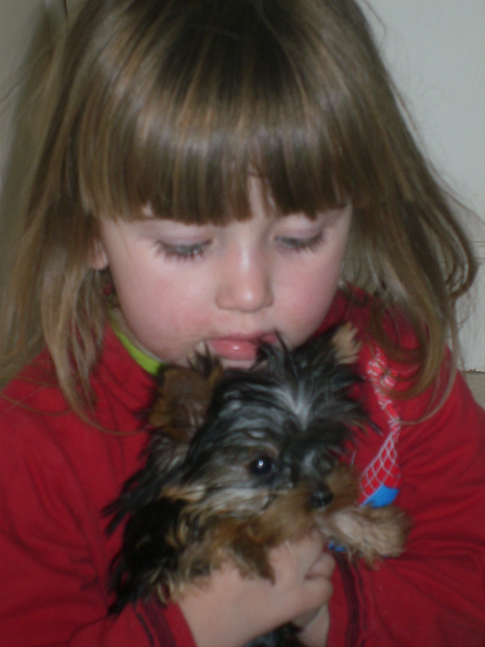
SUSHI – we bid farewell, headed for Dubai during July, we will miss her. SEE FAREWELL.

Hi to you all.

Please take note, we are still seeing TICKS around even in these winter months. Very unusual. Whatever you use to protect your pets continue using it. My Husband had tick bite fever now in June. We use FRONTLINE if you are subjected to ticks, you must treat monthly, even if the insert in the package says otherwise. Three monthly is fine for fleas but definitely not fine for TICKS.

OUR NEWS: Our new website got up and running recently. It did take a good deal of effort and work on my part, but well worth it. The compliments have been flying in, and I know this has nothing to do with dogs, but if you are considering getting a website, please take note. My original website gave me a fair amount of headaches. IT was either hacked, or the service providers system blew up, etc, always something wrong. So after much thought and complaints, I decided to move. IT has been a wonderful experience working with the guys who now host the new site. Extremely professional, not at all like my last bad experience. A website host can refuse to sign the ticket for your website to be transferred to another host???? News to a lot of us. I was fortunate in my old HOST blaming me for so much problems – my website was hacked, I was told by him it was my enemies and furthermore because I am outspoken on my site – NOT TRUE – my new hosts, actually showed me who did the hacking – very interesting indeed. One Turk against the world. He randomly hacks sites ….. I was also blamed for the exHost losing clientele – please - who is the host here – not me. IF you are considering a website, be very careful who you go to.

Back to dogs………….

THE BIEWER YORKSHIRE TERRIER CLUB SOUTH AFRICA……… Due to pressure being put on this club from The IBC we have left America and now are only with the IBC. So in future the Biewer will be referred to as the BIEWER YORKSHIRE TERRIER and not just a BIEWER TERRIER……… this dog originated from the Yorkshire terrier in 1984.

Those of you who have orders with me for pups, we appreciate your patience. The teacup is a rare pup, and we do get a fair amount of them. We have girls expecting that will hopefully give us a few. I have had a few pups from bigger girls recently, and the one’s that produce those small one’s are either mated or due in season anytime now.

Health problems Yorkies are known for.

As in most of the pedigreed breeds some problems arise. Certain breeds are known for certain problems.
The Yorkie is no exception. One of the major problems yorkies are known for is a liver shunt. I have an article on my site that explains this in detail. It is not necessarily the end of the road, for a dog with a shunt. IF you should have a problem or know of someone with a problem, there is a particular Specialist Physician Vet who works very well with dogs with this problem.

Knee problems in the yorkie – Luxating Patella(s)

Extract from the net……
Luxating is a fancy word for dislocating. Patella is your dog's "knee", the joint on the front of her hind leg. So a luxating patella is a dislocating knee or trick knee, a knee that keeps slipping out of its socket. This can happen in yorkies with weak ligaments, tendons, and/or muscles. It can also happen in Yorkies whose kneecap groove is too narrow or shallow. The knee usually slips to the side of the leg, it sometimes locks so that your Yorkie can't bend her leg.
Suspect luxating patella if your Yorkie sometimes lifts one hind leg while she is running, or if she often moves both rear legs at the same time, like a hopping bunny.
Sometimes the knee slips only for a few moments, then slides back into place. Sometimes the knee slips out and stays out, and your Yorkie will hold her leg off the ground and limp, perhaps tucking her thigh into her body. Luxation may occur in one knee, or in both. It is seen in many other toy breeds, and in both sexes, though it seems to be more common in females. No matter how firm the knees seem as puppies, toy dogs are liable to injure their knees.

Joint problems as described above are very common in the yorkie, however having said that, I have had two cases in all these years…… The answer is simple do not breed with dogs with the problem. Another very good thing to bear in mind, do not allow your dog to jump from any height. It is usually the peoples dogs,who end up with the problems,that allow the dogs to jump. Quite a few years back, I visited someone with DUCKS for sale. We have a good collection of Swans and Exotic ducks. This particular lady had six yorkies, all from different breeders and every single one had had its knees operated on?????? I was quite shocked at that. I was not surprised, when I watched from what heights these dogs actually would jump from. Discourage your dogs from jumping.
DRY Eyes
Another problem the yorkie is known for. The first time I came across this must be about 5 years ago. I had sold a pup and the lady returned it saying it had a dry eye. I took it to my vet and we did the test and sure enough the eye was slightly dry at that stage. If one treats the problem it has a good chance of full recovery and in the odd case, you have to continue - life long putting drops into the eye daily. Needless to say we treated that pups eye and it was fine in no time. She saw the dog some months later, and begged me to sell it to her again.
I have since then had it once. So it is not a major problem as such.
That is enough, just now we will all be imagining our animals have one or other ailment.

Letters via the NET……

Hello to you at Mijoy…….
I read your website with much interest. Sometimes for hours on end and find it fascinating to say the least. I have four yorkies. All spayed or neutered. Three girls and a boy. The boy I find no hassle but the girls are at each other, sometimes non-stop. It gets to a stage where I could scream. Have you any advice with regards that. Otherwise they are happy healthy animals. My neighbour has just got a cat, and that they bark at non-stop. Any advice there?
Hope to hear from you shortly
G L Smith
Durban

Hi
Sorry not sure what G stands for. Thanks for your mail. Yorkies in any numbers can cause problems. All you need is one with attitude, but having said that four should not be a real problem. The barking will be irritating, I personally switch off. My Hubby will often say to me tell those dogs to keep quiet and to be honest, I had not even noticed they were making a racket.
You do not give the age of these dogs. I find, you get the different temperaments in dogs, I have a particular dog, and her and her offspring, are all on the bulchy side. She is an old dog now, but that does not stop her picking fights.
Do they really get into a fight that they could do serious damage to one another? OR is it just them airing their opinions.
I always say do not underestimate the YORKIE. They can do serious harm to one another.
IF – they fight that they could do harm to each other, when you go out separate them. I have to otherwise I would come back to blood shed for certain. They are so used to being separated and locked up that they jump in quiet happily to their container or carrier and pass out and sleep till my return. I am never out for any length of time. I also do not go out that often either. I lock some of mine in a bathroom and bedroom, etc, you just have to know who the trouble makers are. As I have said before in nine out of ten cases it is always the girls, who fight. I have quite a few so some share – if you keep them in two’s just make sure the two together get on.
The CAT story. One can hope they get used to the cat eventually. All I would do is call them when they are barking at the cat, distract their attention with toys or a ball. IF they continue – time to start raising your voice. It is quite funny. I am not in the habit of shouting at my dogs. The other night I was really cheesed off – nothing to do with them, and they got the picture from my behaviour. I found some of them looking at me with big eyes as if to say, AND WHAT NOW? It comes back to voice training, which we discussed in an earlier issue of our Newsletter and which I have forwarded to you. YOU should be able to control your dogs, pets with your voice and your voice alone. NO physical punishment is required, if you are the pack leader. Another subject we have discussed.
Hope this helps - you could always resort to ear plugs. Although I knew someone whose dog ate hers……… ended up with major abdominal surgery. MAYBE not such a great idea.

JUST PRIOR TO SENDING THIS NEWSLETTER OFF - a week or so before my little YORKIE rescue MISSY was involved in a dog fight. She is the little girl, that had the broken jaw when she came to us at the end of 2006. Missy has always been very outspoken and a bit of a stirrer. This particular day, a staff member went into my bedroom, where some yorkies were, and they started going at him, which is very normal, and then turned on each other. I was just in the next door room and came flying out. I screamed and the dogs scattered, but then I noticed Missy clawing at her jaw. It was broken again. The damage that was done originally when her owner shattered her jaw, was so severe, that the jaw bones were completely brittle – and every attempt at sorting the jaw this time around, caused a huge problem. She underwent surgery, and a few days later, another surgery was attempted, at that stage she died on the table. She is sadly missed, such a courageous little girl. We were devastated at her loss.

Another thing I have noticed – people leaving their pets with MAIDS again, although we do not agree with this practice. and especially with the tinier yorkie. NO maid will notice a major problem until it is just that, A MAJOR PROBLEM,, I have received two calls recently where the dog was ill while the owner was away and the maid in the one case did mention it to the owner, and in the other case said ZIPPO…… I have said it and brought it to many peoples attention who want the TINY yorkie, that it is not to be left at home and no maid is qualified in looking after these tinies irrespective of how good a NANNY she is. I get the story she reared my children – so what – were your kids less than a kg, some people have even left pups of 300 odd grams with the NANNY – really asking for trouble there.

CHECK LIST
Teeth – have you checked your dogs teeth lately? Do you allow them HOOFIES to aid in chipping of tarar build up?.
Inoculations – Annually from the month of the last vac, provided your dog has had all three initial vacs as a pup. Do Rabies, even if you are not in a rabies area. I have always done rabies, and all my animals. I would rather be safe than sorry. If your dog travels it is also a very good idea to have all vacs and rabies up to date.
Deworm regularly as well. If you are a multi-animal household, more important than ever to deworm regularly. Ask your vet. CHANGE the make of dewormer regularly as well. Dogs can get immune to the same dewormer, and you think you have dewormed dogs and you don’t. Cats as well – deworm.

DOGZ D ZINE
We have launched our new dog gear and fashion. It is a bit slow at this moment. It is not our aim to sell everything and anything, but useful top quality items, and aimed at the smaller yorkie. THIS is not to say we will not supply for the bigger yorkie. We also offer seat covers that attach to the car seat, when the pooch is going out to the vet, this is actually very good idea if you have other bigger breed dogs that loose their fur. We also offer the strollers for those “OUT OF THE ORDINARY” dog lovers. I know of people who have these and swear by them. We have one available for jogging, and the one with the raincoat, and the normal small one. Check out our website for further info. We also sell the cupboard for all the kids gear. That is dog (KIDS). We do ultra fashion as well. I am not one to dress up my dogs, I do put jackets on my very small 600gm dog, but that is for the cold, he really feels the cold in winter. Loads of people dress up their dogs, just REMEMBER, groom, groom and groom when you use jerseys, coats etc. Shortly we will have dog beds, made of sturdy wood, very fashionable and oh so smart for those little woofs in your life. We also can offer you the stairs made from wood, carpet, you name it we can do it. HOWEVER, please do not invest in this for the real small dogs. Just too dangerous.

CONGRATULATIONS:
Congratulations to Deanne of BLINGDOG and her hubby Gavin on the arrival of their first born, GRACE AMBER on 27 June. Her hands will really be full now, what with her beautiful baby daughter and her handful of YORKIES. We look forward to a pic Deanne.

FAREWELL:
We bid farewell in July to Sushi, the baby we have been rearing for Danielle and Marc-Jean for the last few months. The new parents will arrive in South Africa shortly to come and collect their new PUPPY. She is really a stunning little girl, and we have had a fun time in rearing her on their behalf. Time now to say Cheerio to SA and Hello to DUBAI. Best of Luck Danielle and Jean-Marc with this precious pup.

Till next month: THE YORKIE & BIEWER YORKIE: LOVE AND BE LOVED……

